Practical 1:
Aim:
Initiate the semester-long StudentHub portal by identifying the problem
scope, user roles, key modules, navigation flow, and minimum 10 pages.
Create a sitemap, low-fidelity wireframe, project folder structure,
README file, and GitHub repository.

Screenshots:
Wireframe:
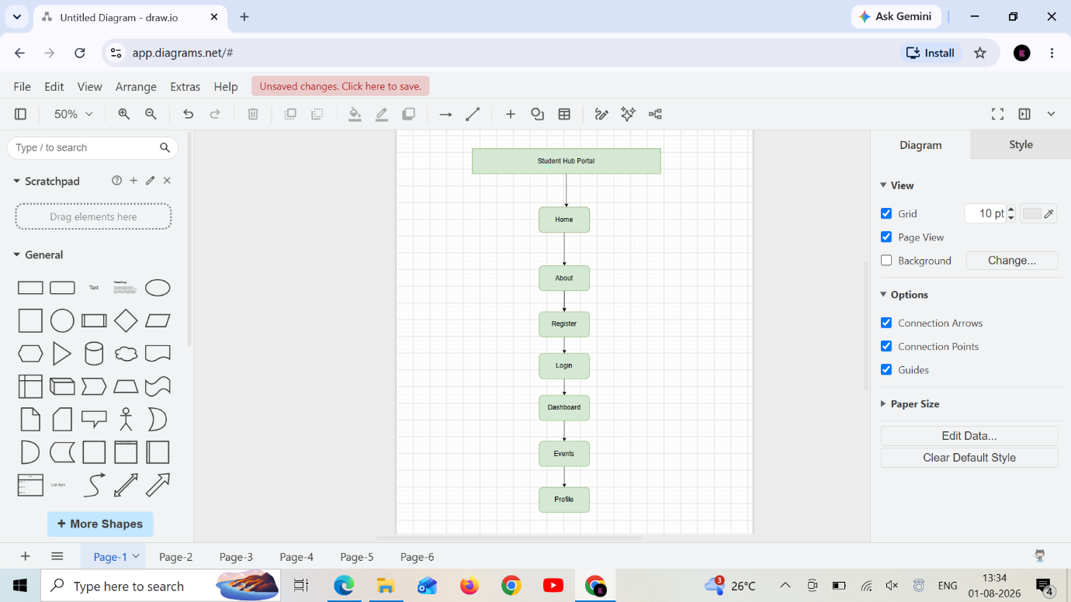
Figure 1-Home page for wireframe

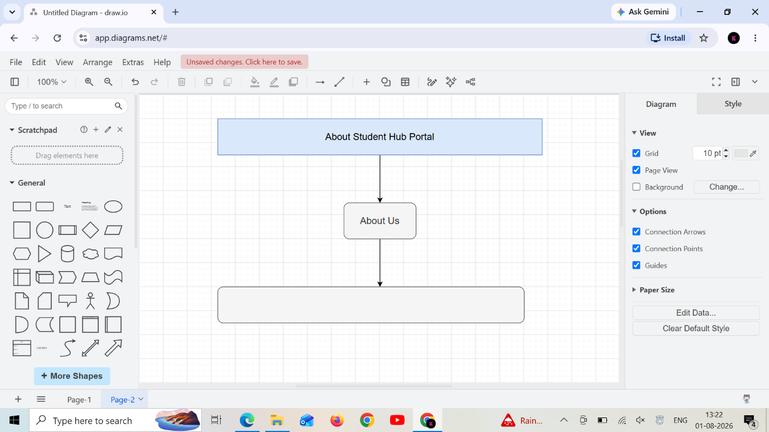
Figure 2-About Page

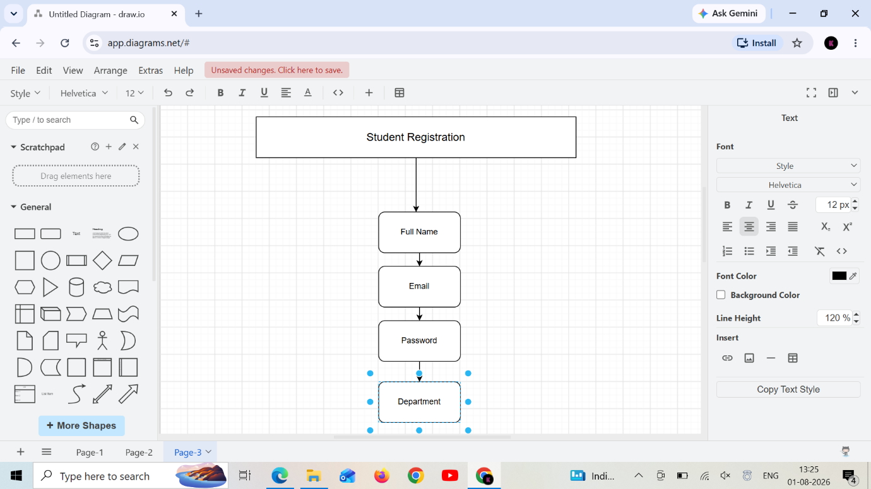
Figure 3-Student Registration
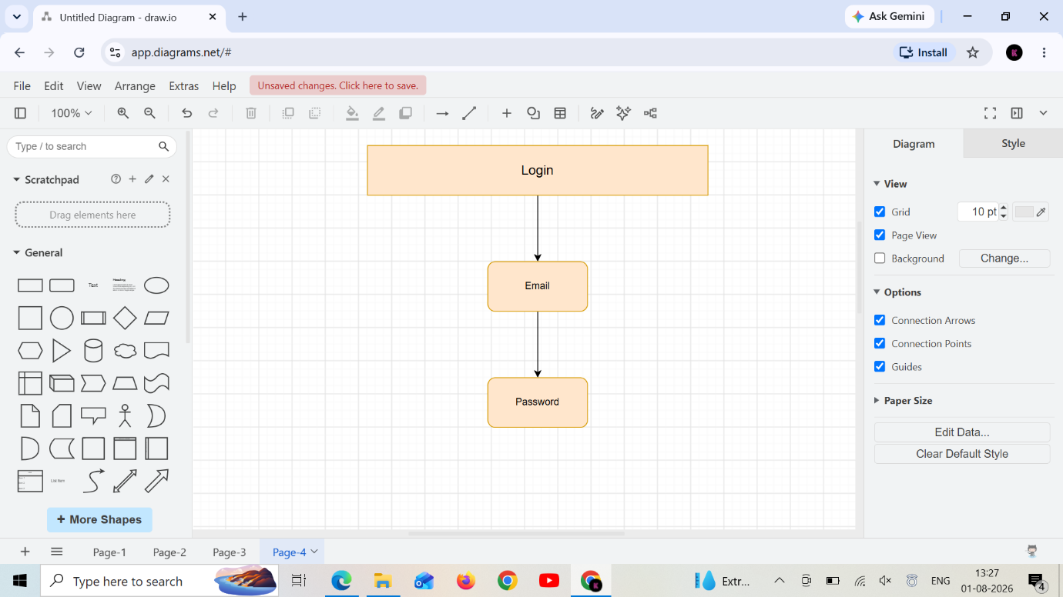
Figure 4-Login
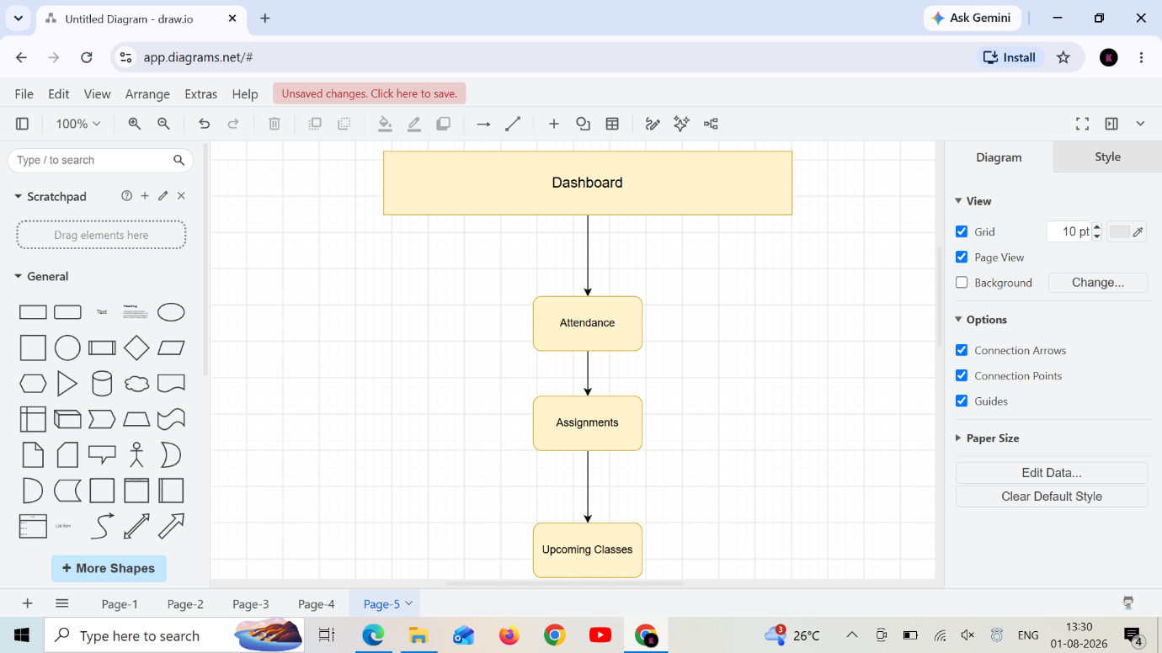
Figure 5-Dashboard
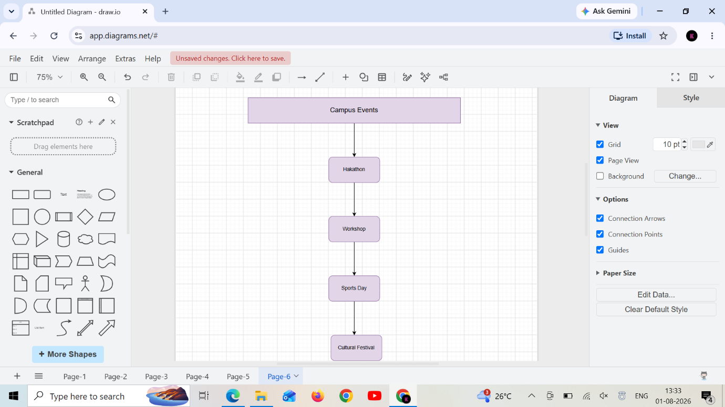
Figure 6-Campus Events
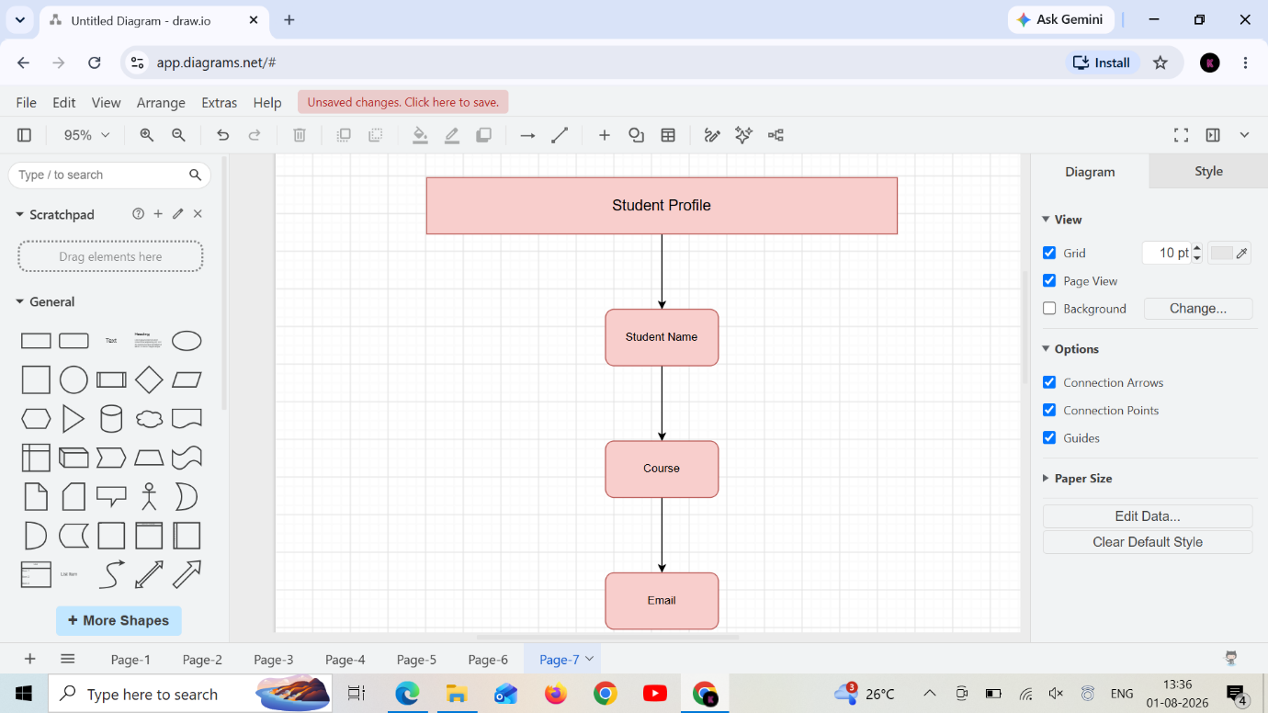
Figure 7-Student Profile
Sitemap:
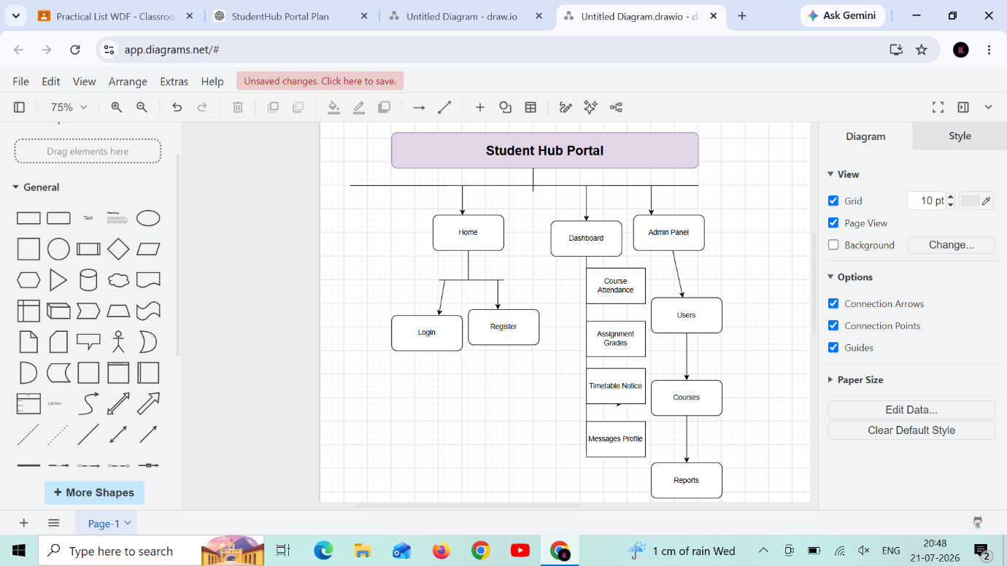
Figure 8-Site map for Student Hub Portal

Learning:
Learnt the concept of how to make sitemap and wireframe in draw.io app.
And structure of designing the web pages.

